

Project Title:
A Secure and Intelligent Banking System
with Fraud Detection

Name | Reg Number | Contribution
Muhammad Abubakar | 2023352 | Backend, Integration
Muhammad Afeef Bari | 2023356 | Frontend, Report
Muhammad Ismail | 2023452 | Frontend, Slides
Shayan Siddiqui | 2023656 | Backend, Integration

1. Project Overview
Bakri Pay is a comprehensive, secure, and modular online banking platform developed as a Database Management Systems project. The system simulates real-world banking operations while incorporating advanced fraud detection, robust user authentication, and a polished frontend for enhanced user experience. Built using Flask (Python) and a layered MVS architecture, it emphasizes scalability, security, and modularity. The project aims to address common challenges in traditional banking systems, including fragmented architecture and weak fraud detection, providing a modern, user-friendly, and secure banking solution

2. Technology Stack:
Front End: Python 3.11, Flask 2.x
Back End: HTML5, CSS3, JavaScript (Vanilla)
Database: SQLite (development), MySQL (scalable deployment)
Project Managment:
Code Hosting: Replit
Authentication: Flask-Login, environment-based config, OTP-based 2FA, role-based access control

3. Entity-Relationship Diagram (ERD)
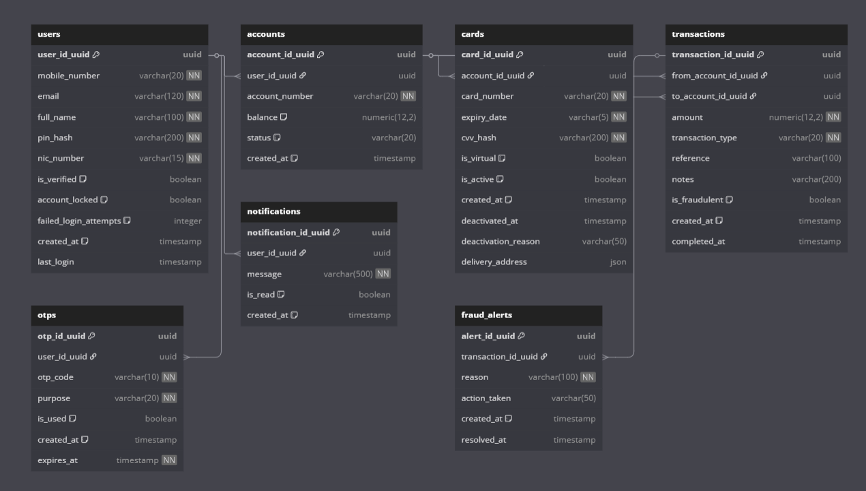
4. Database Schema (Simplified)
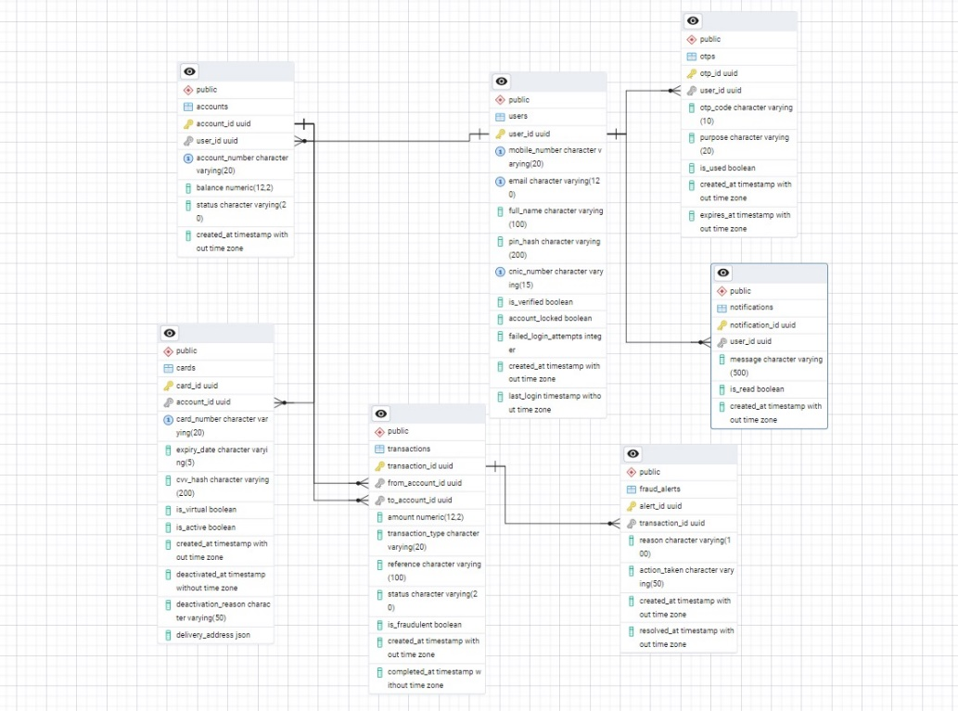
5. Screenshots of Working System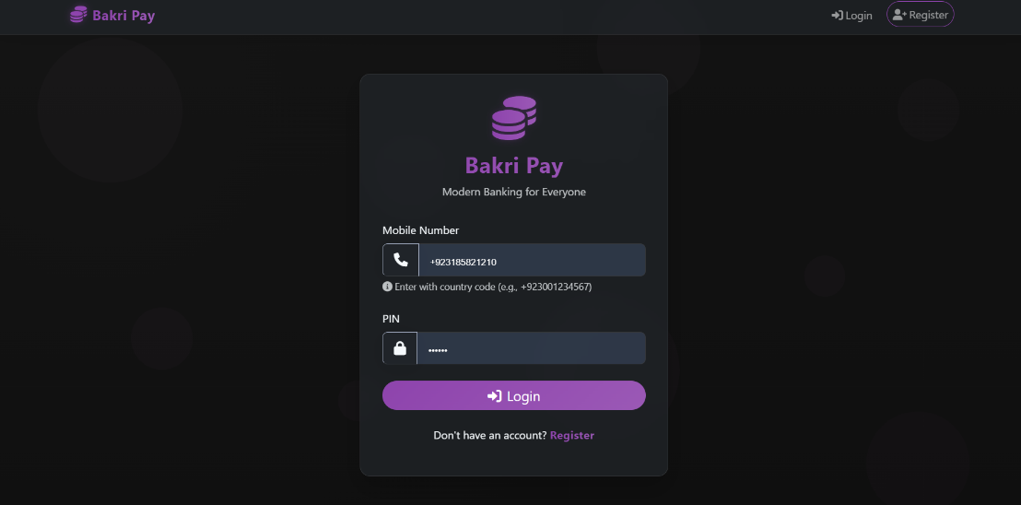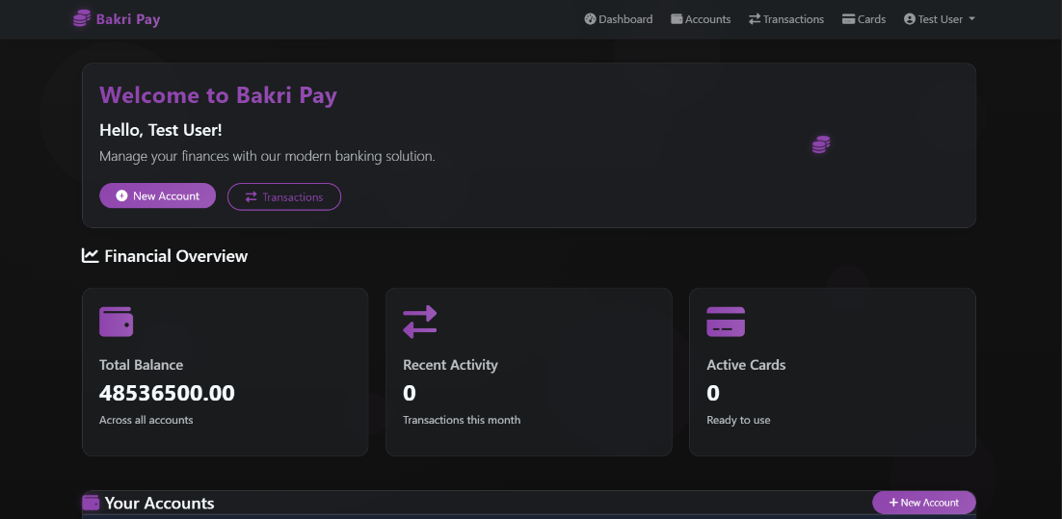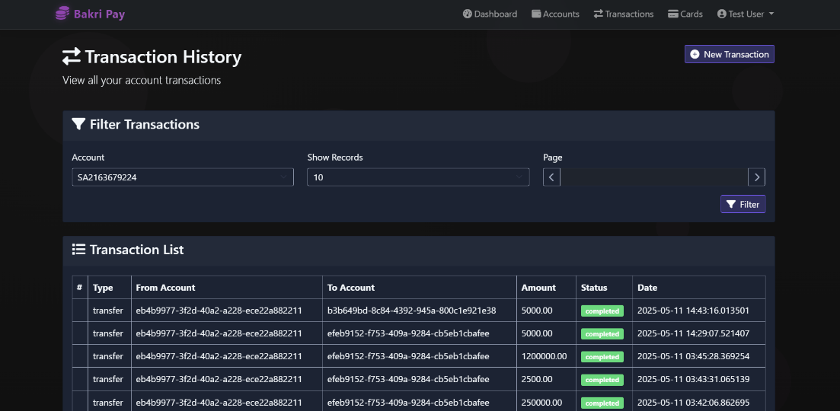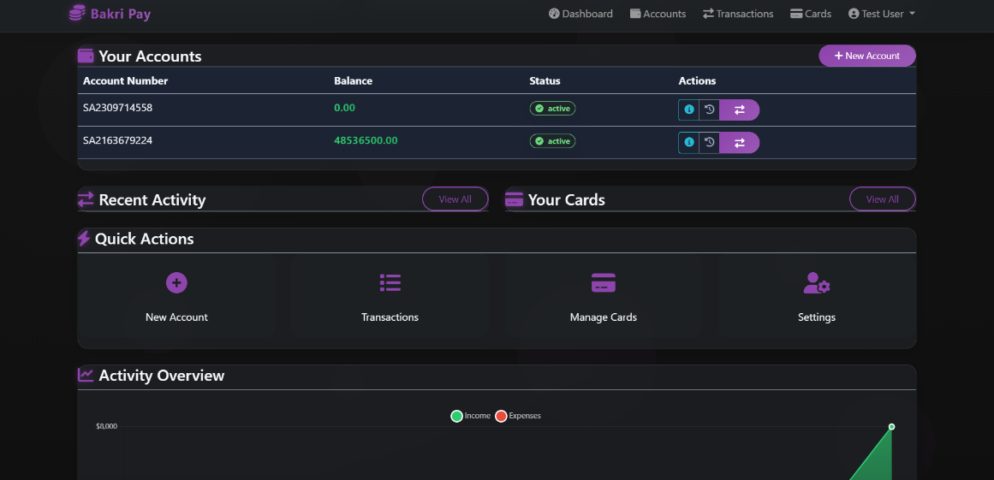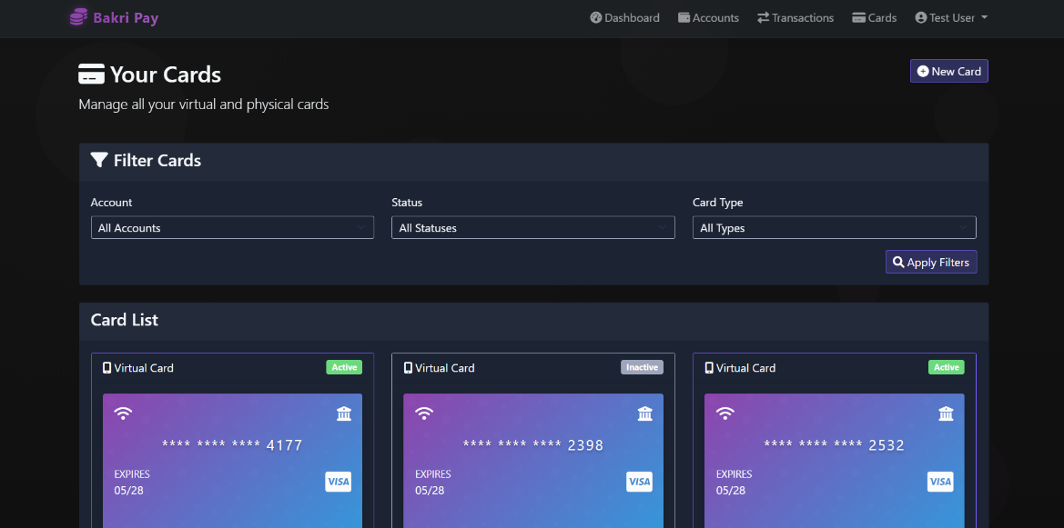
6. Functionalities Implemented
- User Authentication & Authorization: Secure registration, login, password encryption, OTP verification, and session management.
- Account Management: Account creation, deletion, balance inquiry, and detailed account summaries.
- Card Management: Virtual card generation, card blocking, and secure card data handling.
- Transaction Processing: Real-time transfers, transaction history, overdraft protection, and notification hooks.
- Fraud Detection: Rule-based anomaly detection with real-time transaction monitoring and alerting.
- OTP and Notifications: Secure, expirable OTPs for sensitive actions and real-time notifications.
- Utility Services: Data sanitization, error handling, and form validation for enhanced security.
- Bills and Additional Services: Utility bill payments and service provider management (beta version).

7. GitHub Details
https://github.com/shayan1278/A-Secure-and-Intelligent-Baking-System-with-Fraud-Detection-
8. Challenges Faced
- Security Integration: Implementing layered security without compromising user experience.
- Modular Design: Maintaining code modularity while ensuring seamless service integration.
- Scalability: Balancing lightweight development with future scalability needs.
- Fraud Detection Complexity: Designing effective anomaly detection with minimal false positives.
- Database Optimization: Efficient database design to handle high transaction volumes without lag.
- Cross-Module Communication: Coordinating data flow across multiple modules without introducing bottlenecks.

9. Future Enhancements
- AI-based fraud detection using user pattern clustering
- Mobile application (Flutter/React Native)
- Real-time analytics dashboard
- Biometric integration and adaptive security
10. Conclusion
Bakri Pay successfully simulates a real-world banking platform with a strong emphasis on security and user experience. The project demonstrates the power of modular software architecture, making it a valuable academic exercise and a potential blueprint for future financial technology solutions. The incorporation of fraud detection, OTP-based authentication, and modular service components highlights the team's focus on building a secure and scalable banking system.

